2020-2025

Sun 10-3  
Mon 10-3  
Wed 1-6  
Thurs 1-6

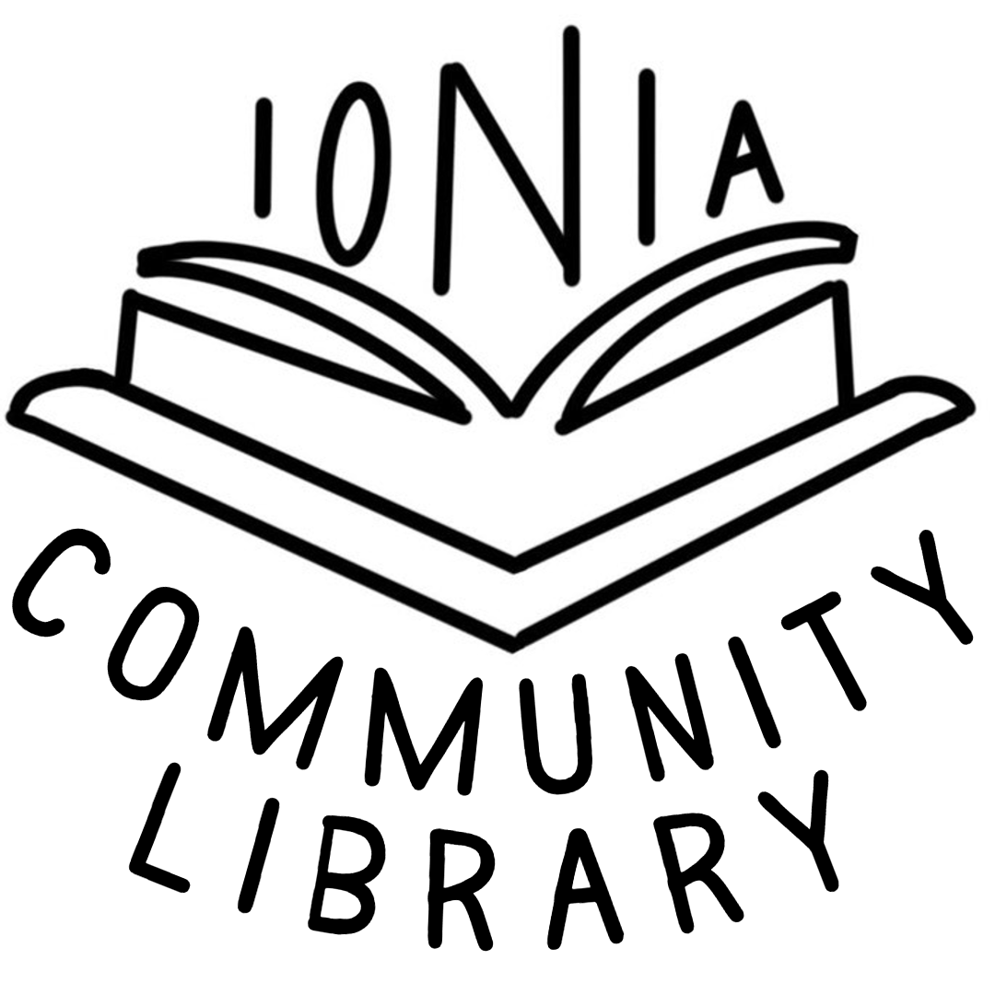

**Ionia Community Library**

**101 W Iowa St**

**Ionia, IA 50645**

**Mission Statement:** The primary mission of the Ionia Community Library is to be the local information resource center for leisure and learning and to provide that information in a reliable, safe and non-intimidating environment to our patrons in an attempt to lead them from childhood to being life-long readers and learners.

**Goals and Objectives:**

Goal #1: To have hours of library service convenient to the population of this community.

Special attention will be given to the students and working population, so that they too have access to the library.

Objective: Maintain consistent hours, 20 hours per week. Be open four days with two evenings, and two mornings. Have a qualified/trained staff on duty to provide full service to the patrons and community.

Goal #2: The Ionia Community Library will continue to provide in-demand reading material in the form of books, audio books, and magazines for all reading levels.

Objective: Will continue to maintain budget spending on the book collection paying special attention to popular adult fiction, children’s fiction. (2020-2025) Regularly evaluate non-fiction and reference books, prioritizing print purchases and utilizing internet sources (2020-2025). Prioritize weeding of outdated materials, especially non-fiction, and upgrade the Young Adult (YA) collection with relevant and well-maintained materials (2020-2025), based on documented use of request forms for the reconsideration of library materials for review by the board.

Goal #3: The Ionia Community Library will encourage use of online resources, including platforms like Libby and BrainFuse, among patrons.

Objective: Enhance staff training to effectively guide patrons in utilizing online tools, ensuring they are well-versed in the features and benefits of each resource (2022). Develop and implement outreach programs to educate the community about the benefits and accessibility of these free digital resources (2023). Regularly update the library website and communication channels to highlight the availability and convenience of these online resources (2024). Allocate a specific budget to support the acquisition and promotion of online resources, fostering a seamless transition towards a more digital-friendly library environment (2025) based on the needs and interests of the community.

Goal #4: The Ionia Community Library will strive to keep up with the ever changing technology needed to operate today’s library

Regularly evaluate current technology, updating public computers to meet patron needs based on documented assistance provided for patron tech support services (2020-2025). Enhance the library website and social media pages continually, making improvements based on metrics of engagement and event attendance. Encourage public utilization of library technologies.

Objective: An evaluation of current technology will be done and necessary changes will be made.

Librarian will continue to train in the various technologies, especially in classes offered through the state and area services. (2020-2025) Library staff will continue to encourage public use of our technologies for education, vocation, and recreation.

Goal #5: The Ionia Community Library will provide programs for various ages and group types

Objective: With the demographic information of the population we serve in mind, plan and present programs for different age groups, with a minimum of ten children's and ten young adult/adult programs annually (2020-2025). Utilize external resources when necessary. Allocate a specific budget line for program funding based on expected attendance (2020-2025). Continue providing an annual city program for Ionia Days.

Goal #6 Space Maintenance of the Ionia Community Library

Objective: Regularly evaluate library space and building, implementing changes as necessary (2020-2025). Enhance the outdoor space of the library. Optimize the use of storage space (2024).

Goal #7: Provide access to all individuals who research genealogy and heritage by having library resources that encourage a better understanding of their heritage and the heritage of others.

Objective: Foster a rich and well-organized genealogical and historical exploration experience for our community members by curating an extensive collection of resources that will not only cater to the specific inquiries of patrons and those inquiring about their ancestry in Ionia but also actively promote a deeper understanding of their heritage and the shared heritage of our rural town (2025).

Overall Goal: Provide more services to more people year over year.

Review: We have updated our technology (2019), installed new lighting (2020), incorporated a grant-funded Makerspace into the children’s section (2023) and enhanced the interactive, attractive environment with two chalkboard walls (2023).We will continue to enhance the usability and beauty of our building as we maintain and expand our services and programming.

India Watson

Library Director

641-394-4803

101 W Iowa St  
Ionia, IA 50645